How to Set Up Moltbot (Clawdbot) in 5 Minutes

One-click Moltbot setup on DigitalOcean (5 minutes, non-devs)
Alex McFarland
Jan 29, 2026

DigitalOcean just released a one-click Moltbot droplet (VPS) that makes setup ridiculously easy. No more VPS configuration hell. No more spending hours troubleshooting. Just click, set up, and you’re running your own AI assistant in under 5 minutes.
This is the fastest way to get Moltbot (formerly Clawdbot) running if you’re a non-developer.
By the end, you’ll have:
- Your own Moltbot instance running on DigitalOcean — isolated, ready to use
- Terminal access to your bot — speak to it, give it context, set it up
- Web dashboard access — monitor activity and manage your instance
- Connection options for Telegram/other platforms — message your bot from anywhere
- Context profile onboarding — how to feed your bot everything about your business in seconds
No coding. No complicated VPS setup. Just a couple clicks and you’re running.

Why Moltbot?
If you’ve been watching AI tools evolve over the past few years, Moltbot is the thing that actually feels like the future.

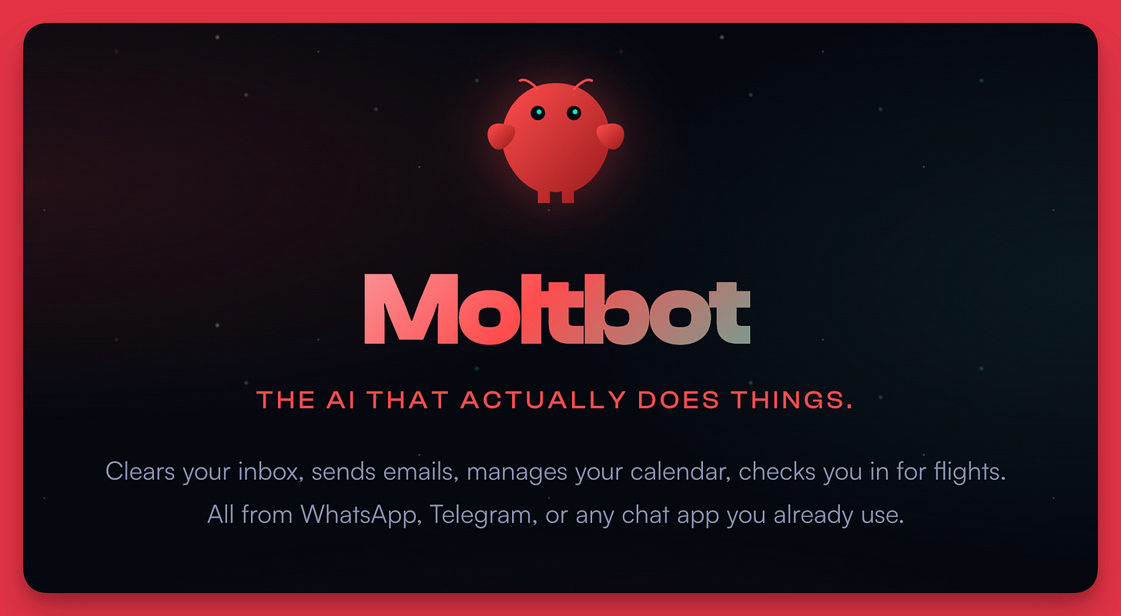

It’s Claude Code on steroids. An autonomous AI that can work across your entire system—clearing inboxes, managing calendars, checking you in for flights. But the real power is what happens when you connect it to your workflows. When you give it access to your Obsidian vault, your context profiles, your project files. When you text it like you’d text an assistant and it just handles things.
I’ve been working with AI for 6-7 years, building co-writing systems and non-developer workflows. This is the most excited I’ve been about anything in that entire time. Not because of hype. Because of what it actually does and what it means for the direction we're heading.
The problem has always been setup. Running it on a VPS meant dealing with SSH keys, configurations, security settings—stuff that makes non-developers give up. Running it on a Mac Mini (which is what I do) works great but requires hardware and a full local setup.
Now DigitalOcean made it one-click.
Share

What’s in the video
0:00 Intro
0:25 What is Moltbot (quick overview)
1:48 Two ways to run Moltbot (Mac Mini vs VPS)
2:44 DigitalOcean one-click droplet
3:10 Creating your Moltbot droplet
4:30 SSHing into your VPS
5:45 Connecting your Anthropic API key
6:30 Launching Moltbot TUI
7:15 Accessing the web dashboard
7:45 First conversation with Moltbot
8:30 Onboarding with context profiles
10:15 Naming your Moltbot
11:00 Connecting to Telegram and next steps

Why DigitalOcean’s droplet matters
Before this, setting up Moltbot on a VPS meant:
- Installing dependencies
- Configuring security settings
- Setting up gateways and authentication
- Troubleshooting environment issues
DigitalOcean pre-built all of that. Their droplet comes with:
- Moltbot already installed
- Security features baked in (authenticated gateway tokens, firewall-level rate limiting, non-root execution, container sandboxing)
- Multi-channel messaging gateway support (WhatsApp, Telegram)
- Private DM pairing
You click “create droplet,” pick your server size, set a password, and you’re done. Moltbot is ready. That’s the entire setup.

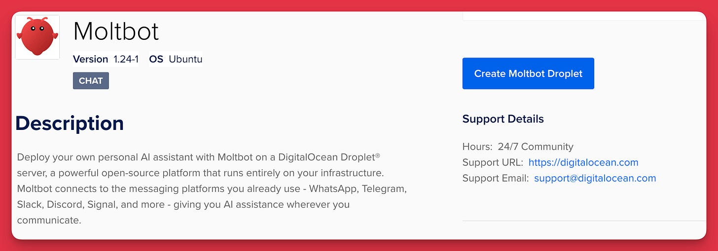

The two camps: Mac Mini vs VPS
There are two main approaches to running Moltbot:
Mac Mini approach:
- Buy a Mac Mini, create a separate Apple account for it
- Give it full system access
- Integrate with iMessage
- Text your bot like you’re texting a real assistant
- AirDrop files to it, message it all day
This is what I do. I have a Mac Mini running 24/7 with my Moltbot fully integrated into my workflows. It’s insane. But it requires buying hardware and setting up a local environment.
VPS approach:
- Run Moltbot on a cloud server (DigitalOcean, AWS, etc.)
- Access it via terminal or web dashboard
- Connect to Telegram/WhatsApp for messaging (Telegram is safer/easier)
- No hardware required, just a monthly server cost
DigitalOcean just made the VPS approach stupid easy. For non-developers, this is the way.

Context profile onboarding
The biggest unlock with Moltbot is feeding it context about you and your business. The more it knows, the better it works.
You have two options:
- Talk to it: When you first launch Moltbot, it asks who you are, what you want to call it, what your work is. You can speak (or type) through all of that. Use voice dictation. Just dump everything.
- Feed it a context profile: If you already have a JSON context profile of your business (like I do), you can paste the entire thing in and onboard in seconds.
A context profile (included below) is a structured document that captures:
- Your name, role, expertise
- Your business model, offerings, pricing
- Your audience and positioning
- Your products and services
- Your methodology and frameworks
I use these for everything—Claude Code, Moltbot, any new AI tool that comes out. I own my context. I don’t re-explain my business every time. I just feed the profile and the tool knows everything immediately.
Moltbot saves all of this to markdown files (user.md, soul.md, etc.) that define how it operates and what it knows about you. The more detailed you are, the better.

What you can actually do with this
Once Moltbot is running, the real work begins. You’re not just setting up a chatbot. You’re setting up autonomous infrastructure.
Some ideas:
- Connect it to your Obsidian vault and have it work on your notes, drafts, and knowledge base
- Feed it your co-writing system context and use it as a parallel agent for content production
- Integrate it with your calendar, email, and project management tools
- Text it throughout the day with tasks and let it handle them asynchronously
- Build custom skills and workflows on top of it
This is the foundation. The actual power comes from what you (and everyone else) build on it.

PAID MEMBER RESOURCES:

Context profile creator
If you want to build a complete context profile for your business (so you can onboard AI tools instantly), I have a full prompt that walks you through it.
The prompt helps you document:
- Business overview — what you do, who you serve, your positioning
- Offerings — products, services, pricing, delivery
- Audience — ICP, pain points, language patterns
- Methodology — your frameworks, processes, core beliefs
Once you have this, onboarding any AI tool becomes trivial. Just paste and go.
💎 Click here to access the business profile context prompt

Additional Resources
- Moltbot on DigitalOcean Marketplace
- Moltbot Website

This is infrastructure. The more you use it, the more powerful it becomes.
I’ll be dropping more Moltbot content soon—integrations, workflows, and everything I’m building on top of this.
Let’s go.

